Login Screen Redesign
A before/after comparison of the app's login screen, moving from a bare wireframe to a polished, branded UI.
Overview
 | Before | After
Layout | Plain white background, no header | Full mobile frame with status bar and "Back" nav
Branding | None | Deep indigo/blue wave graphic, top and bottom
Heading | None | "Welcome back!" greeting
Fields | Unstyled gray blocks labeled "username" / "password" | Bordered input fields with floating labels ("Email", "Password") and placeholder text
Password field | No visibility toggle | Eye icon to show/hide password
Extra options | Plain text: "forgot password?, sign up?" | "Remember me" checkbox + styled "Forgot password?" link
Primary action | None visible | Filled indigo "Login" button
Social login | None | "Or connect with" divider + Google, Facebook, Apple icons
Sign up | Plain text link | "Don't have an account? Sign up" with styled link text
Screenshots
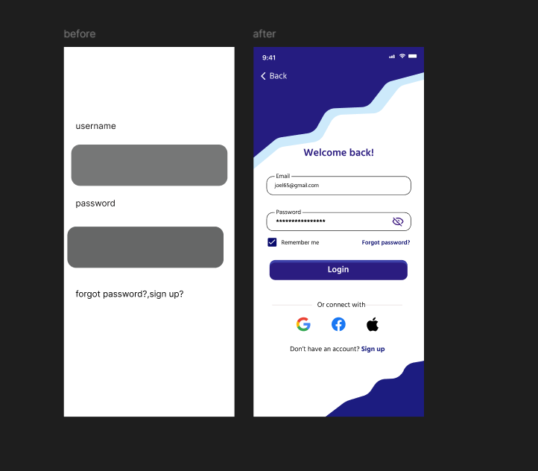

Key Improvements
- Visual hierarchy — A clear heading, grouped fields, and a prominent CTA button guide the user through the flow.
- Branding & personality — The indigo wave motif and color palette give the screen a distinct identity instead of a generic wireframe.
- Usability enhancements — Password visibility toggle, "Remember me," and clearly separated "Forgot password?" reduce friction.
- Alternative auth options — Social login icons (Google, Facebook, Apple) offer faster sign-in paths.
- Polish — Real placeholder content (e.g. sample email, masked password dots), consistent spacing, and rounded input fields make the screen feel production-ready rather than a placeholder mockup.
Notes
This document summarizes a visual design comparison. No code or assets are included — it's a written record of the changes for design review/handoff purposes.

